**1. What is the advantage of using a “reverse proxy server”?**

A **reverse proxy server** increases the capacity of existing servers. Serve more requests for static content and thus free up bandwidth to serve more dynamic content. Reduce operating expense by increasing bandwidth. Provide a single point of control over who can access HTTP servers, and which servers can be accessed.

**Host a site** [**ABC.COM**](http://abc.com)

**2.Why and where Nginx is a better choice than apache.**

**NGINX** is about 2.5 times faster **than Apache** based on the results of a benchmark test running up to 1,000 concurrent connections. ... Clearly, **NGINX** serves static content much faster **than Apache**. If you need to serve a lot of static content at high concurrency levels, **NGINX** can be a real help.

**3. What are worker nodes and worker connections? How to calculate the max server capacity using the above two?**

The *worker* processes do all of the work! They handle network connections, read and write content to disk, and communicate with upstream servers.Each worker process is single‑threaded and runs independently, grabbing new connections and processing them. The processes can communicate using shared memory for shared cache data, session persistence data, and other shared resources.

Worker connections tells **worker processes** how many clients can be served simultaneously by Nginx. The default value for this is 768 but it's important to keep in mind that each browser will usually open at least 2 server connections.

**4. From what directory will NGINX automatically load server (virtual host) configurations when using the default /etc/nginx/nginx.conf configuration?**

**5. How to configure different log_format for different “location” block/directive?**

**6. Create an index page and a fail-safe page. If a page for URI is not available, the fail-safe page is served.**

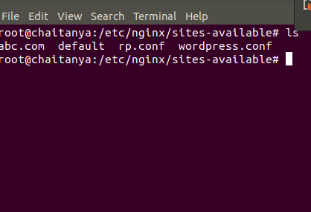

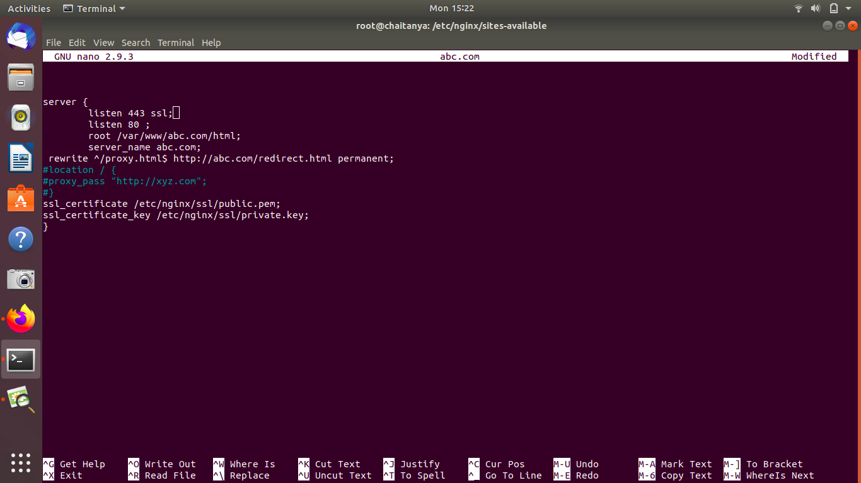





**proxy pass to a website** [**xyz.com**](http://xyz.com) **on a particular URI.**

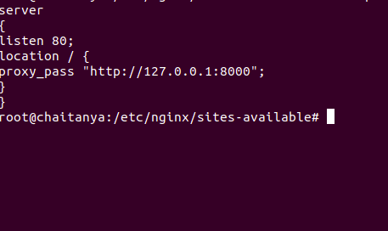



**redirect to above URI on /redirect/**



**perform an HTTP to HTTPS redirection including non-www to www redirection.**

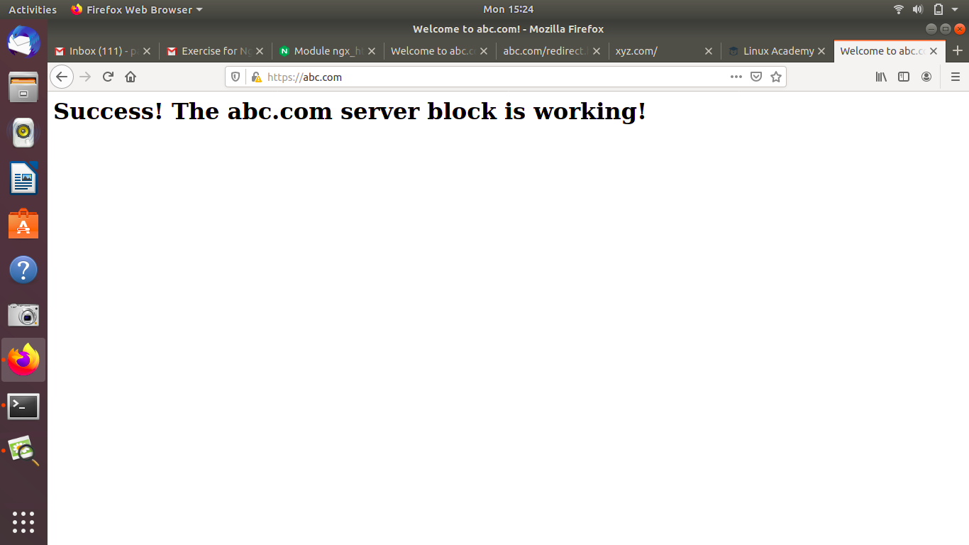

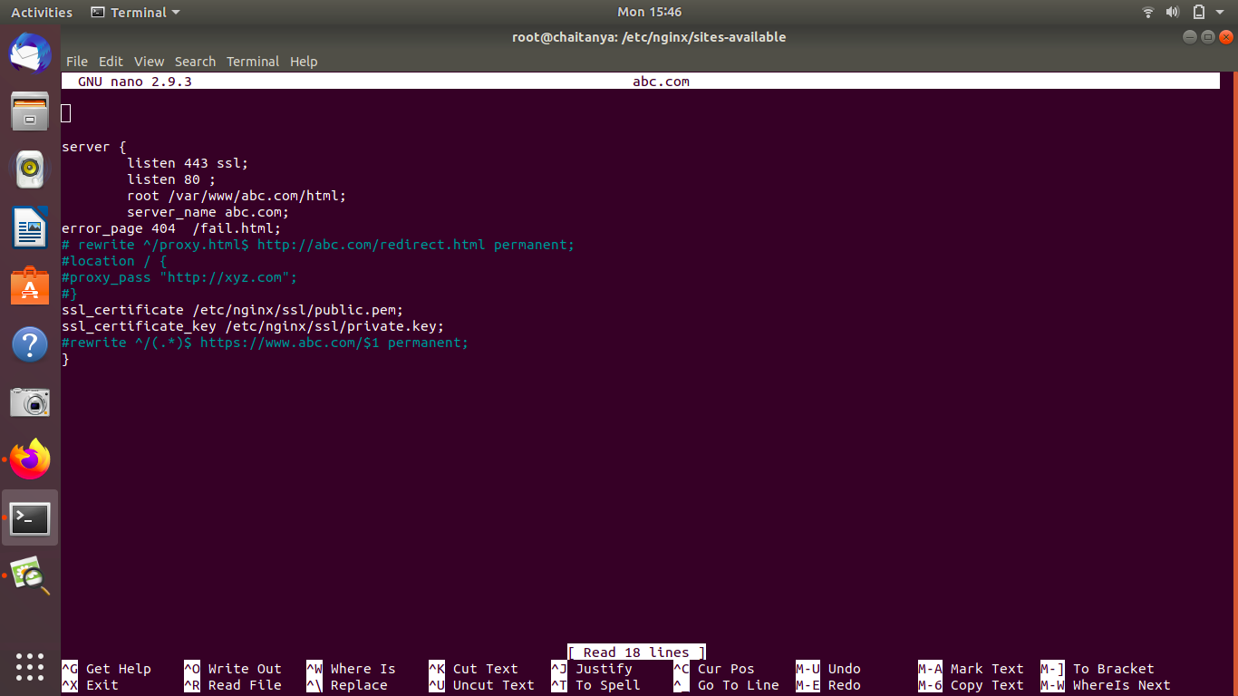

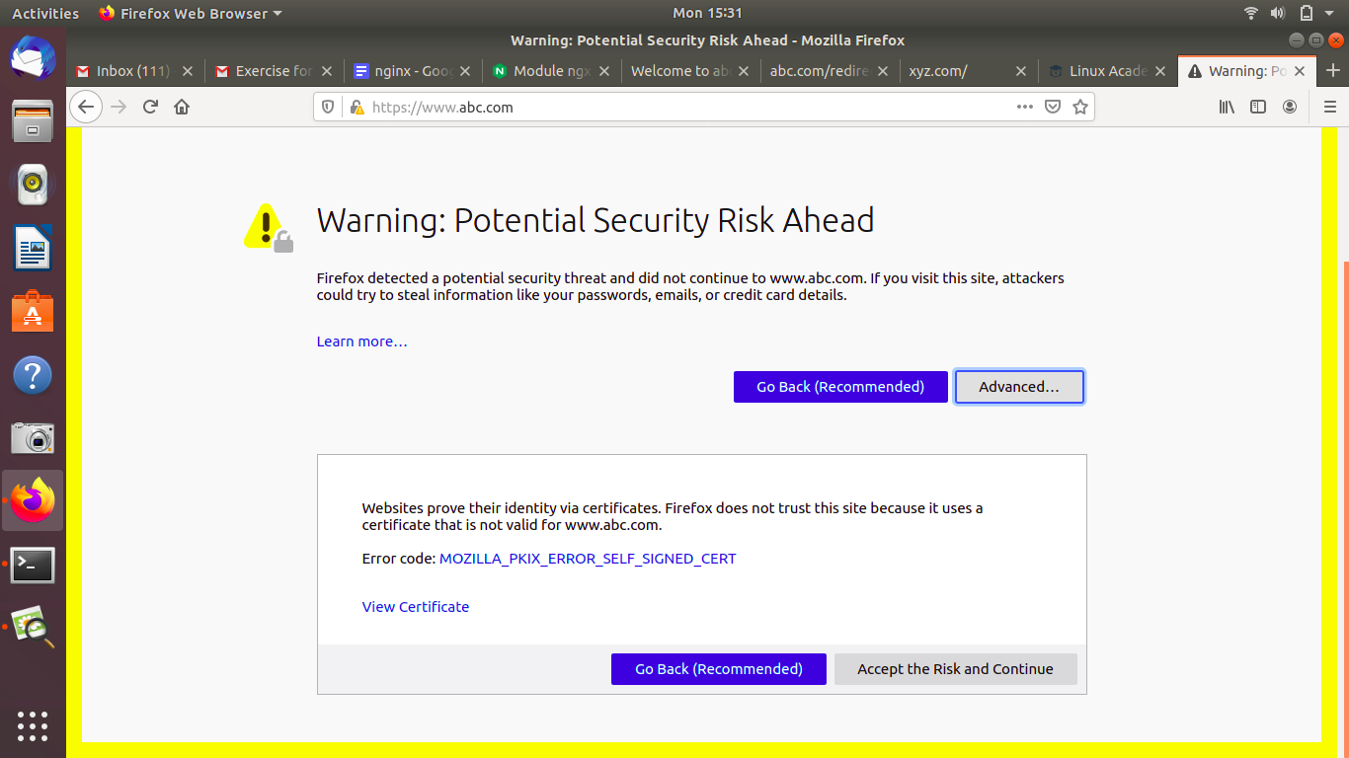

**Allow access to a set of particular IPs on a location block and return 405 to other IPs no matter if the page in that location exists.**

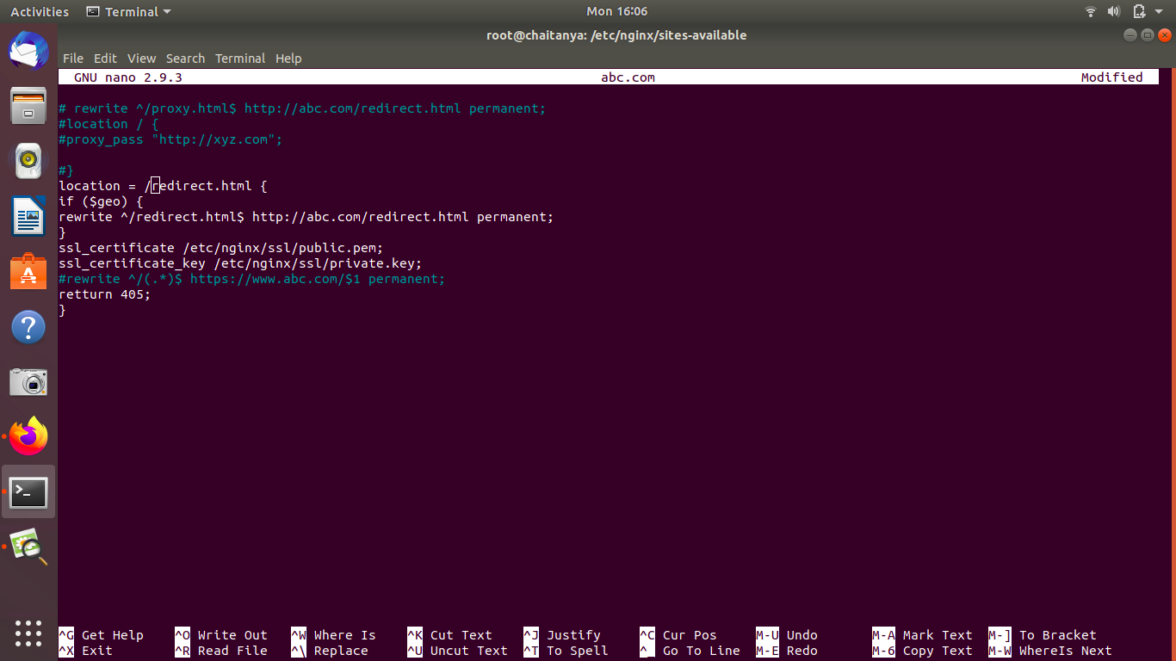

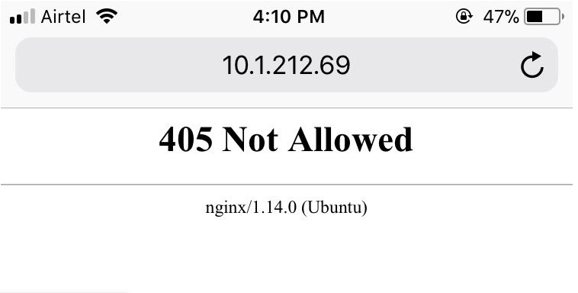

**7. Create a load balancer with 5 backends. Explain different types of load balancing methods.**

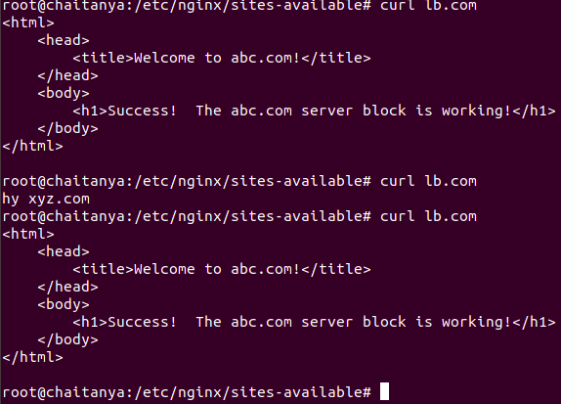

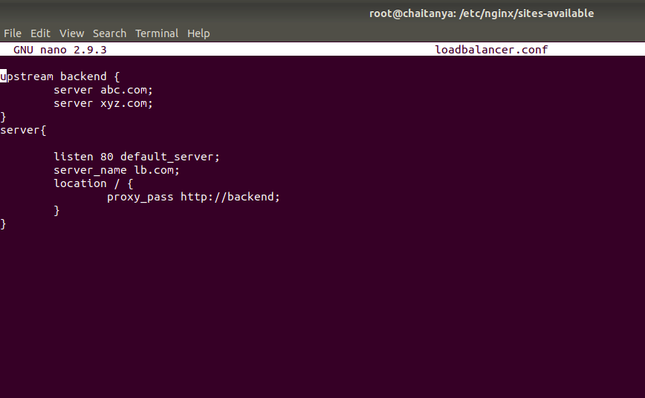

**8. Setup Basic Auth (Popup asking for username and password) in a particular location block. (The Basic Auth should not be asked for TTN IP)**

